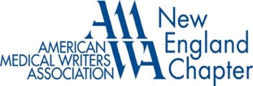

Judy Linn Membership Awards
Application Form

The New England Chapter of the American Medical Writers Association (AMWA-NE) awards a one-year free membership in AMWA (which includes chapter membership) to qualified newcomers to the field.

To be eligible for the award, candidates must:
- Live and work in New England
- Have no more than three years of full-time experience as a medical writer
- Not be an existing AMWA member for more than one year or a previous AMWA member

To apply, please complete the form below and send the following as part of your application:
- Your resume
- A brief statement describing your interest and ambitions in the medical and health communications field
- Two samples of your writing in health- or science-related fields

Name: Click or tap here to enter text.

Home Address: Click or tap here to enter text.
Phone Number: Click or tap here to enter text.

Email: Click or tap here to enter text.

Employer: Click or tap here to enter text.

Job Title: Click or tap here to enter text.

Work Address: Click or tap here to enter text.

Work Phone: Click or tap here to enter text.

Please submit your application form and all the required documents to AMWA-NE Membership Awards Committee Chair:
(awards@amwa-ne.org)

